Cantaloupe Recall
Official Statement
8/24/2012
Marvin’s Produce LLC is not affected by the current recall of domestically grown cantaloupes. The genesis of this outbreak has been isolated to Chamberlain Farms in Owensville, Indiana; c.f. Food and Drug Administration and Centers for Disease Control and Prevention as of August 17, 2012.
Marvin’s Produce has never purchased produce from this grower. Marvin’s Produce has not done business with or purchased from, other purveyors that have been affected by this recall.
The FDA has identified the states where the cantaloupes have been shipped; Illinois, Indiana, Kentucky, Missouri, Ohio, Tennessee and Wisconsin. South Carolina was not part of the distribution from Chamberlain Farms.
Out HAACP team as well as our Management staff is monitoring this, as well as all FSIS recalls that involve produce. We proactively update any recalls that may affect our clientele on our website, marvinsproduce.com, in coordination with the USDA FSIS hyperlink located at the bottom of the homepage.
Again, Marvin’s Produce LLC is not affected by the current recall of domestically grown cantaloupes from Chamberlain Farms in Owensville, Indiana.
Please contact me by email, kolby@marvinsproduce.com if there are any questions or concerns that have not been addressed.
Thank you,
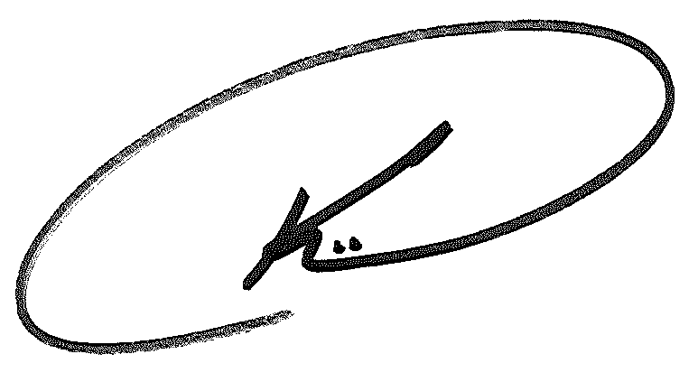
Kolby Garrison
General Manager
Marvin’s Produce LLC

